Описание картинки

Describing the picture | Speculating about the situation
This picture (photo) was taken in…/ I took this photo when I was in …  The picture shows …  In this picture you can see …  There is … in this picture.  On the right …  In the left hand corner …  In the foreground you can see …  There is/are… in the background.  In the bottom of the picture there is/are…  There are … in the top part of the picture.  The people in the picture are …  The people in the picture look happy because …  The people in the picture seem sad because …  The general atmosphere in the picture is positive (cheerful) because …  The general atmosphere in the picture is depressing because …  The weather in the picture is … | It can be…  It may be …  They could be …  Perhaps …  It is probably …  Another idea is that …  It is also possible that …  It seems to me that people in the picture …  I get the impression that people in the picture are not happy because …  They don’t seem to be enjoying themselves because …

Expressing an opinion | Clarifying | Listing points  Adding information | Emphasis | Giving reasons
I think,…  I believe,…  I suppose,…  It seems to me that…  As I see it,…  In my opinion,…  I tend to think that…  From my point of view,… | By this I mean…  In other words,…  The point is…  In fact,…  Actually,… …especially…  …particularly… | Firstly,/To begin with,…  Secondly,…  Furthermore,…  Moreover,…  In addition,…  Also,…  Apart from this,…  Besides,… | Of course,…  Obviously,…  Indeed,…  Naturally,…  Definitely,… | …because…  …as…  …so…  That’s why…

Пример выполнения задания
In your talk remember to speak about:
      - What does the picture show (weather, foreground,
centre, background ...)
      - what/who is in the photo
      - what is happening, what are people doing
      - what are their feelings, emotions
      - what do you think about the picture
You have to talk continuously.

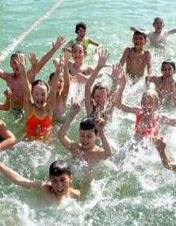1. 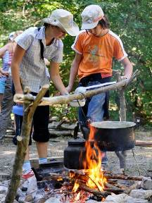 2.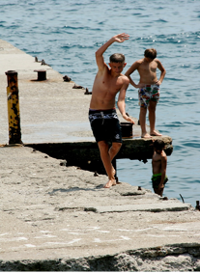3.

Примерный вариант ответа учащегося ( картинка 2)

The picture shows one of the most interesting holiday activities. It’s cooking over an open fire. The weather is fine and it’s possible to cook in the open air. In the foreground, you can see two kettles of tea and a pot of soup over the fire. In the middle, you can see two camp members, Marina and Vlad, standing by the fire. In the background, some other teenagers are collecting wood for the fire.
- Marina and Vlad are keeping an eye on the meal. At this very moment they are spooning out some soup into the plate in order to taste it. They seem to be extremely concentrated on the process.
- I think they feel great responsibility as they are preparing food for the whole camp group.
- In my opinion, such kind of activity is very exciting for the campers, especially for those who has never gone camping before.
- I’ve never been to a camp. I’d like to get some experience in camping and to spend holidays in a camp. I’m sure, it’s worth doing.
- All in all, I like the photo and, perhaps, next summer I will take pictures in the camp myself.

